## Sustainable Smart City Assistant Using IBM Granite LLM

## 1. Introduction

Project Title: Sustainable Smart City Assistant Using IBM Granite LLM

Team ID : LTVIP2025TMID20299

Team Members:

Team Leader: Jakku Kumarswami

Team member: Garikipati Tripura

Team member: Gandham Sravya Kalavathi

Team member: Gonam Kailash

## 2. Project Overview

The Sustainable Smart City Assistant is an AI-powered platform built using IBM Watsonx Granite LLM and Streamlit. It enhances citizen interaction, sustainability monitoring, and urban data understanding.

**Key Features:**

**• Policy Summarization:**

Upload city policy PDFs and receive citizen-friendly summaries.  
**• KPI Forecasting:**

Upload historical data to predict city performance metrics.  
**• Anomaly Detection:**

Detect unusual patterns in consumption or KPI data.  
**• Eco Tips Generator:**

Get AI-generated sustainable living tips.  
**• Feedback Reporting:**

Citizens can report issues under categories like water, electricity, roads, etc.  
**• Chat Assistant:**

Ask general questions about sustainability or city services.

## 3. Architecture

The solution uses a four-layer architecture:  
• UI Layer (Streamlit): Sidebar navigation, file uploaders, text inputs, and chat interface  
• Application Layer: Handles file parsing (PyMuPDF, pandas), prompt formatting, API calls  
• AI Service Layer: IBM Watsonx Granite 3B/13B model for generating natural language responses  
• Session Layer: Uses Streamlit session_state for maintaining inputs and chat history

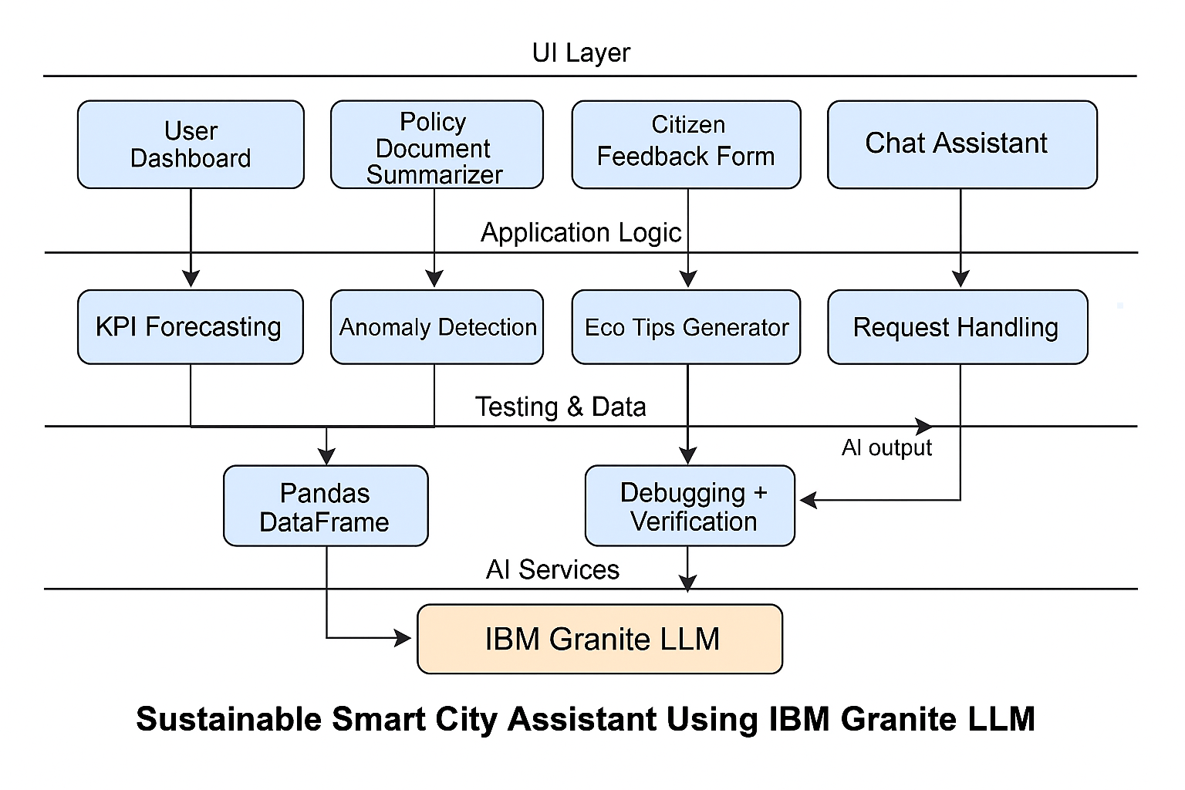

## 4. Setup Instructions

1. Install Python 3.8+ and pip.

2. Create and activate a virtual environment.

3. Install dependencies: streamlit, pymupdf, ibm-watsonx-ai, python-dotenv.

4. Create a .env file with IBM_WATSONX_API_KEY and URL.

5. Run the app with: streamlit run app.py

## 5. API Documentation

The system uses IBM Watsonx Granite 13B via the ibm-watsonx-ai SDK. The ask_watsonx() function manages prompts for all modules.

The backend "API" in this project is primarily the interface with the IBM Watson Machine Learning service. There are no traditional REST API endpoints exposed by a separate backend server (like Node.js/Express.js) as this is a Streamlit-based application directly interacting with the AI service. The primary "API" calls are made internally to the IBM Watson Machine Learning service: ¬ Service: IBM Watson Machine Learning ¬ ModelUsed: IBMGranite 13B Instruct v2 (ibm/granite-13b-instruct v2) ¬ Authentication: API Key and Endpoint URL, managed securely via .env file and loaded by python-dotenv.

## 6. Authentication

API credentials are securely stored in a .env file and accessed using python-dotenv. These are used to authenticate with Watsonx AI services.

Authentication with the IBM Watson Machine Learning service is handled via an API Key.

* TheAPIKeyisobtained from the IBM Cloud account associated with the Watson Machine Learning service instance.
* Itis securely stored as an environment variable in the .env file within the project directory.
* Thepython-dotenv library loads this API key at application startup.
* Theibm_watson_machine_learning.credentials.Credentials class uses this API key along with the service URL to authenticate with the IBM Watson Machine Learning API when initializing the Model object. This ensures secure communication without hardcoding sensitive information

**7. User Interface**

The user interface of Sustainble Smart City is designed using the Streamlit framework, emphasizing modularity, clarity, and ease of interaction for developers, testers, and project managers.

**Main Application Layout**

* **Page Title & Layout**:  
  The application sets a custom page title ("SmartSDLC – AI Assistant") and uses a wide layout for enhanced code readability and output formatting.
* **Sidebar Navigation:**  
  A prominent sidebar (st.sidebar.radio) allows users to switch between six major modules:
  + Policy Search & Summarization
  + Citizen Feedback Reporting
  + KPI Forecasting
  + Anomaly Detection
  + Eco Tips Generatorr
  + Chat Assistant
* **Session Management:**  
  st.session_state is used to retain chat history and form input across module switches, ensuring a consistent experience.
* **UI Customization:**Though Streamlit does not support native CSS styling out-of-the-box, optional custom CSS can be added using st.markdown with unsafe_allow_html=True for visual enhancement if needed.

**Feature-Specific Interfaces**

Each module in the Sustainable Smart City Assistant is implemented as an isolated, user-focused interface within the Streamlit dashboard. These modules are optimized for individual urban tasks and enable effective interaction with IBM Watsonx Granite LLM.

1. **Policy Search & Summarizatio**n
   * Upload interface for PDF policy documents using file_uploader
   * Optional: Text area for manual policy input
   * AI-generated summaries displayed in a structured, citizen-friendly format using st.text_area
   * Spinner animation shown during processing, with success confirmation upon completion
2. **Citizen Feedback Reporting**
   * Selectbox to choose feedback category (e.g., Water, Electricity, Roads)
   * Text area for users to describe issues
   * Submit button logs the entry with confirmation feedback
   * (Future scope: Integrate with backend database for feedback tracking)
3. **KPI Forecasting**
   * CSV upload interface for last year’s city KPI data (e.g., water usage, electricity consumption)
   * DataFrame preview shown for validation
   * LLM processes data and forecasts future trends
   * Output shown in a text box with labeled insights
4. **Anomaly Detection**
   * CSV upload module for detecting outliers in KPI data
   * Uses pandas to parse input and display the data preview
   * AI analyzes and flags potential anomalies in the dataset
   * Outputs a plain-language description of irregular patterns or spikes
5. **Eco Tips Generator**
   * Text input to specify a keyword (e.g., plastic, electricity, solar)
   * Generates 5 personalized eco-lifestyle tips using the LLM
   * Output shown as a bulleted markdown list
   * Lightweight interface for quick sustainability awareness
6. **AI Chatbot Assistant**
   * Interactive chat window using st.chat_input and st.chat_message
   * Maintains multi-turn interaction with history via st.session_state
   * Accepts open-ended questions about sustainability, urban governance, or environmental impact
   * Displays assistant replies in conversational format

**Dynamic Visualizations (Optional / Future Scope)**

Although the current version is text and data-centric, the architecture supports extendable visual interfaces such as:

* + Usage Heatmaps:

Monitor which modules are most frequently used

* + Anomaly Charts:

Graphically visualize spikes and irregularities in city metrics

* + Sentiment Charts:

Analyze citizen feedback using sentiment scoring

* + Forecast Trendlines:

Visualize historical vs. predicted KPI performance

* + Eco Tip Engagement Graphs:

Track keyword popularity over time.

## 8.Testing

## Smart City project follows a structured testing strategy to ensure functionality, reliability, and a smooth user experience across all AI-assisted modules.

## Unit Testing (Conceptual)

## Focuses on verifying the correctness of individual functions, such as:

## ask_watsonx(): Ensures it sends well-structured prompts and returns valid AI responses.

## PDF parsing using PyMuPDF: Tests that requirement text is accurately extracted from uploaded PDFs.

## Session state handling in Streamlit: Confirms chat history and module input/output persist across user actions.

## Integration Testing

## Validates the end-to-end workflow between frontend (Streamlit) and backend (IBM Watsonx AI):

## Ensures correct prompt construction for each module (Policy Summarizer, KPI forecasting , etc.).

## Verifies successful API calls to the Watsonx Granite 13B model and appropriate output rendering.

## Tests module switching and ensures that state is preserved without breaking the application.

## User Acceptance Testing (UAT)

## Involves manual testing by actual users (developers, testers, or mentors) to ensure the tool:

## Meets defined expectations for each task.

## Generates relevant and context-aware responses from natural language inputs.

## Provides a user-friendly experience in terms of navigation, output clarity, and functionality.

## Error Handling Tests

## Verifies robustness of the application by simulating error scenarios:

## API Errors: Broken Watsonx connection or invalid credentials handled via try-except blocks.

## Input Validation: Checks for empty or invalid user input (e.g., no Summary entered before clicking “Summarize ”).

## Session Failures: Confirms fallback behavior if session state is not initialized or corrupted.

## 9. Known Issues

• Session state lost on app refresh.  
• No user authentication implemented.  
• API limits may affect high-volume use.

## 10. Future Enhancements

• User login system with profile persistence.

• Store feedback in a backend database (e.g., Firebase, Cloudant).

• Advanced analytics on Kpi Forecasting and Anamoly Detection.

• Expand support for multiple languages.

**11. Screenshots**

